I. Preprocessing
# 1. Explore the structure of the dataset
# 2. Quantify and visualize missingness
# 3. Identify implausible age and zBMI values
# 4. Clean growth data using WHO-style plausibility cut-offs
# 5. Generate a cleaned dataset for downstream analysis
- # 3.1 Percent missing per variable”?
- Missingness exploration:
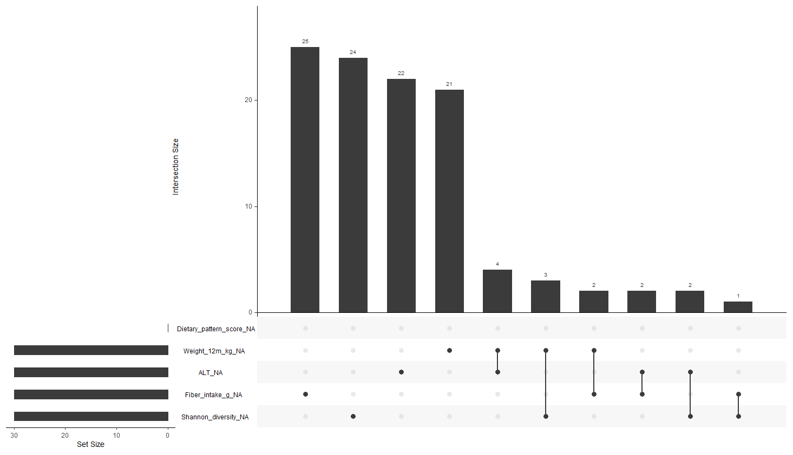
  - Top Bar Plot
    - # of observations with a specific missing-data pattern
  - Dots and Lines
    - which variables are missing in that intersection
      - Filled dot → that variable is missing
      - Empty space → that variable is observed
      - Connected dots → variables that are missing together
  - Left Horizontal Bars
    - # of missing values per variable
- Missingness by subgroup?

- Distribution GGplot (zBMI):
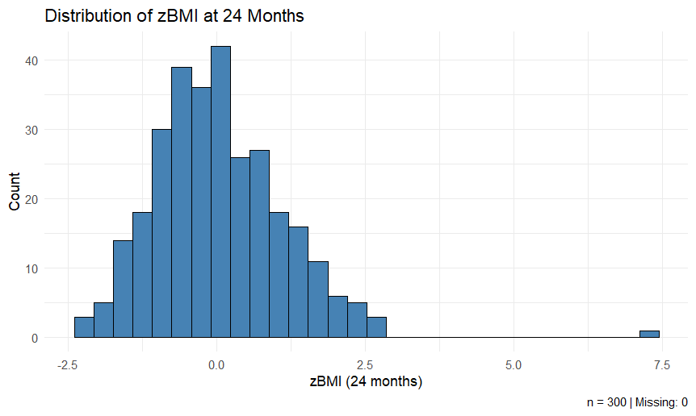
- Distribution GGplot (CRP):
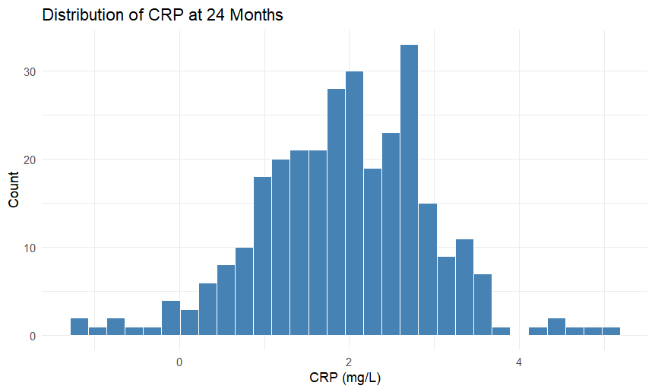
- Implausible values exploration?

- WHO-style plausibility cut-offs for zBMI:
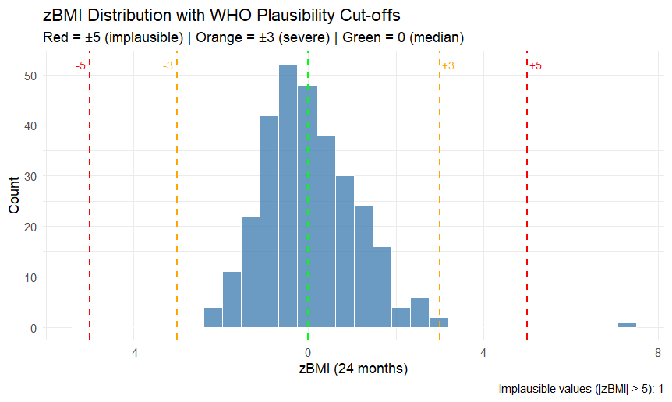
- Extreme CRP values:
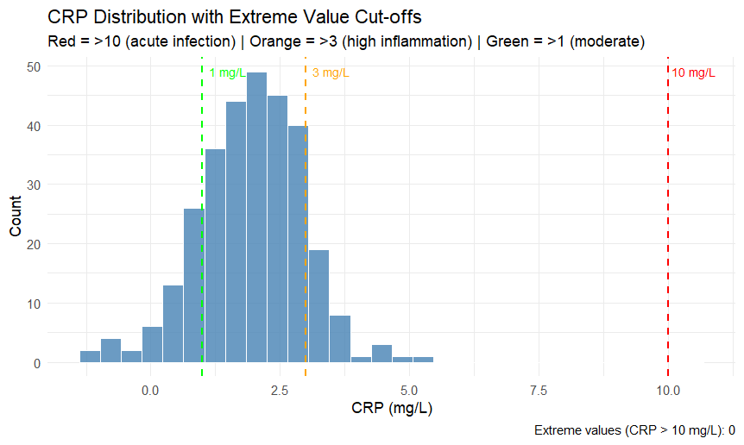

- Data cleaning:
> cat("Original rows:", nrow(data), "\n")
Original rows: 300
> cat("Clean rows:", nrow(clean_data), "\n")
Clean rows: 295
> cat("Rows removed:", nrow(data) - nrow(clean_data), "\n")
Rows removed: 5
- Recalculate missingness:
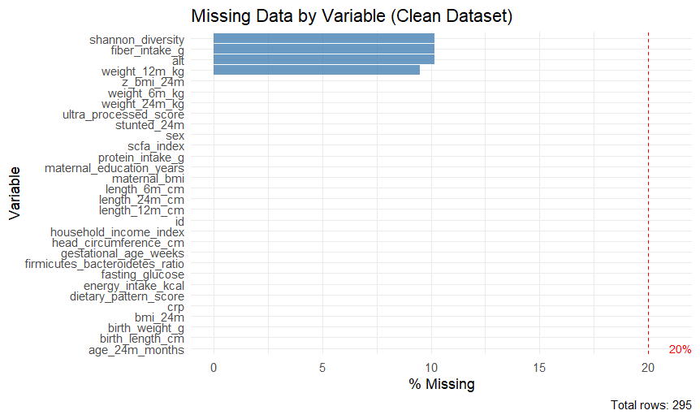

II. Assessing Cluster Tendency
# We will start by describing why clustering tendency is necessary before applying any clustering method on data. Next, we will apply visual and statistical visual methods for assessing the clustering tendency.
- Testing 1 (Raw Data):
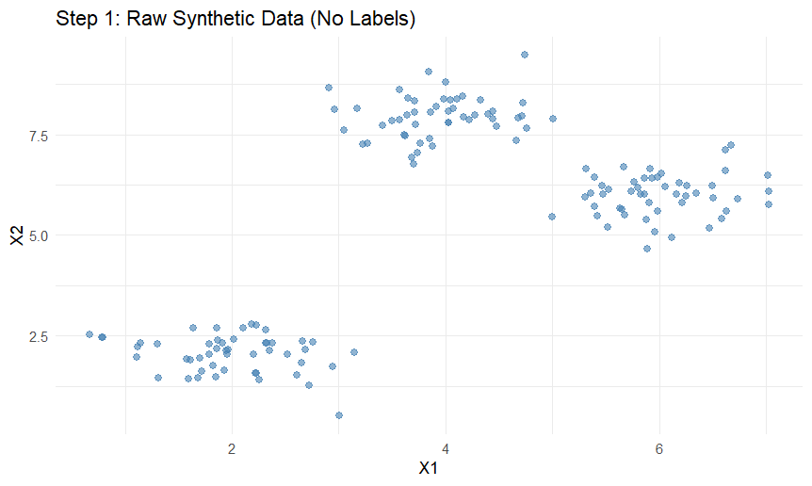
- Testing 2 (Add labels):
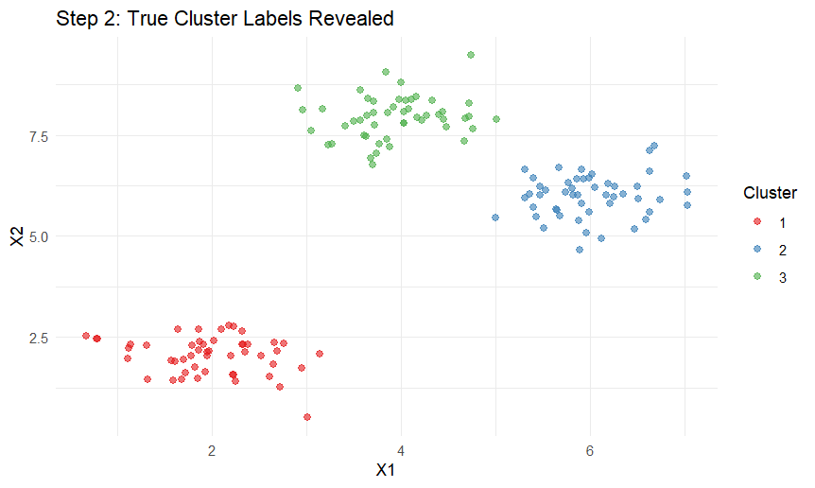

- Testing 3 (Scale the data):
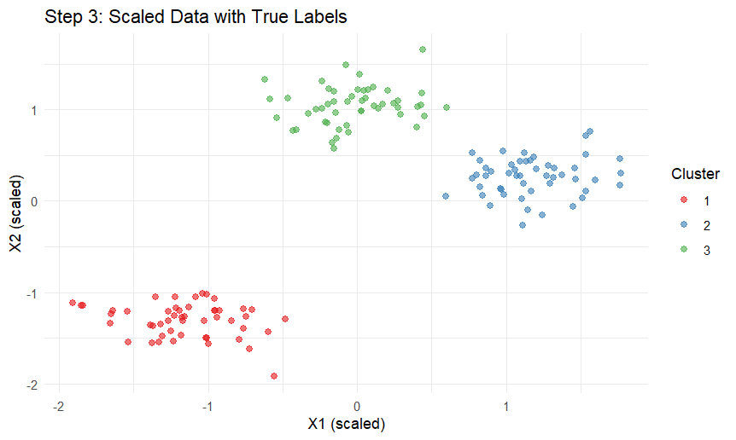
- NBClust Method:
  - Using a different statistical method to vote on the best number of clusters between min.nc (2) and max.nc (8)
  - Using distance Euclidean and method K mean
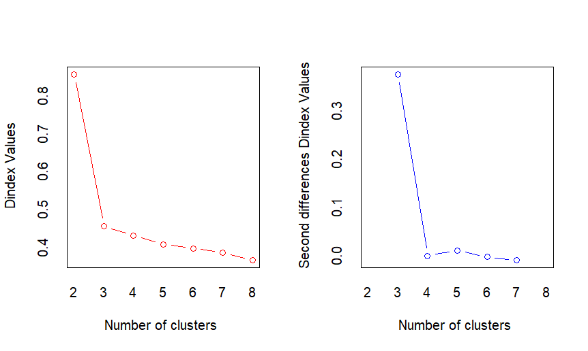
    - “According to the majority rule, the best number of clusters is 3”
- K mean voting:
  - Saving the best number of clusters as optimal K mean

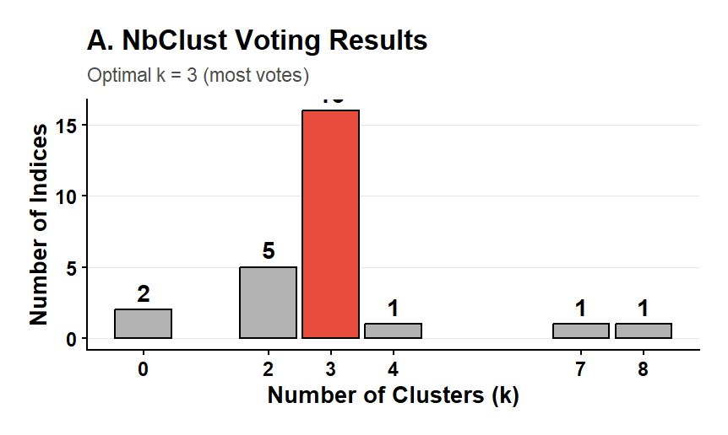
- Elbow Method:

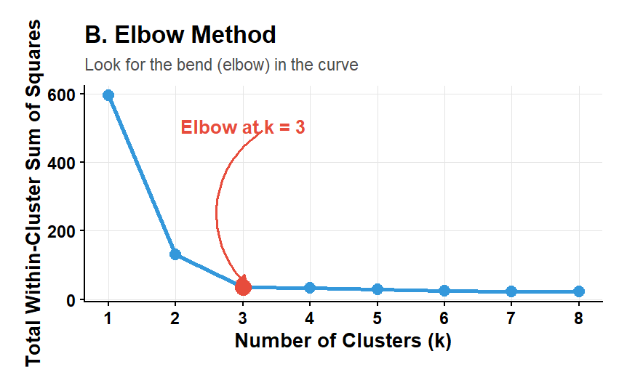

- Silhouette Method:
  - Works with any distance metric, detects cluster separation, numbers, and cohesion
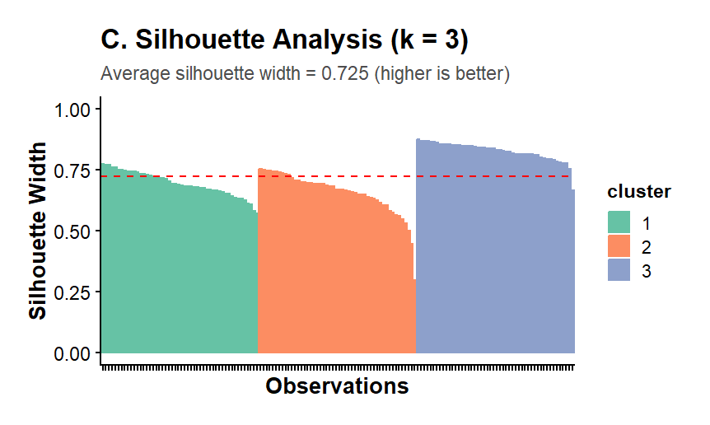
- Cluster Visualization (PCA):
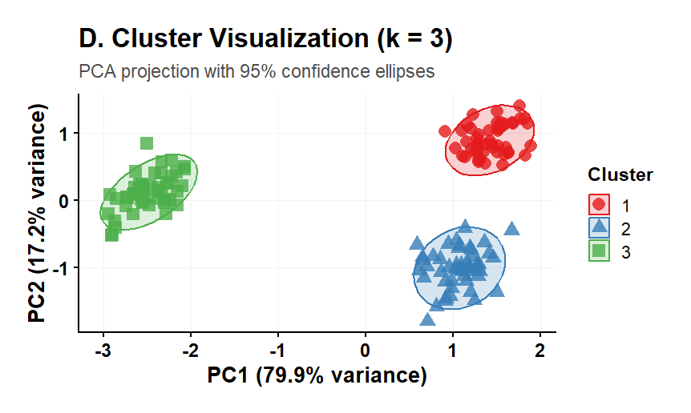

- Comparing different k means:
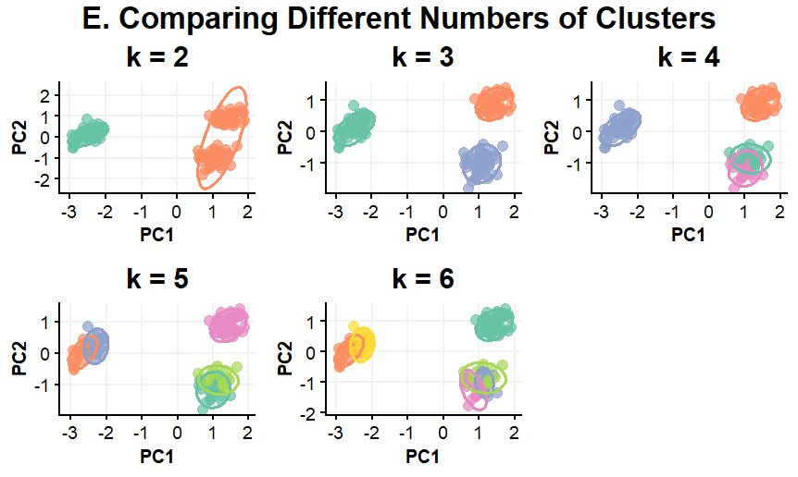
  - Results show a strong separation (non‑overlapping ellipses) between the three groups which supports k = 3

- Index heatmap:
  - To create matrix showing which k each statistical index voted for
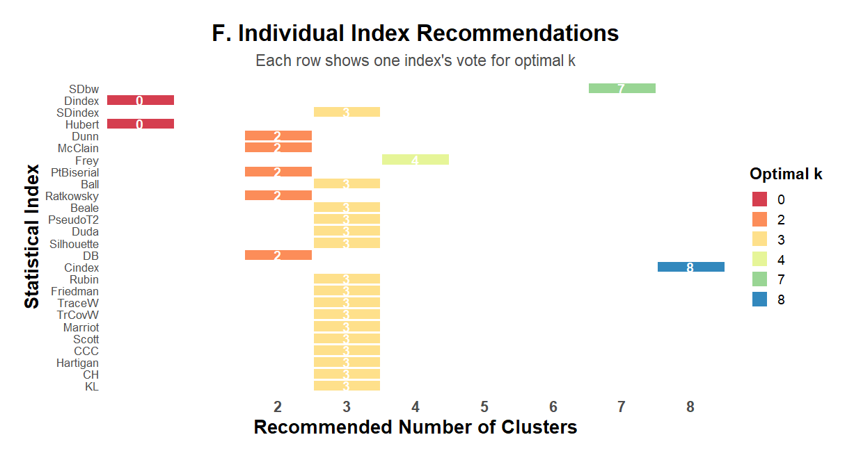

- Putting everything together:
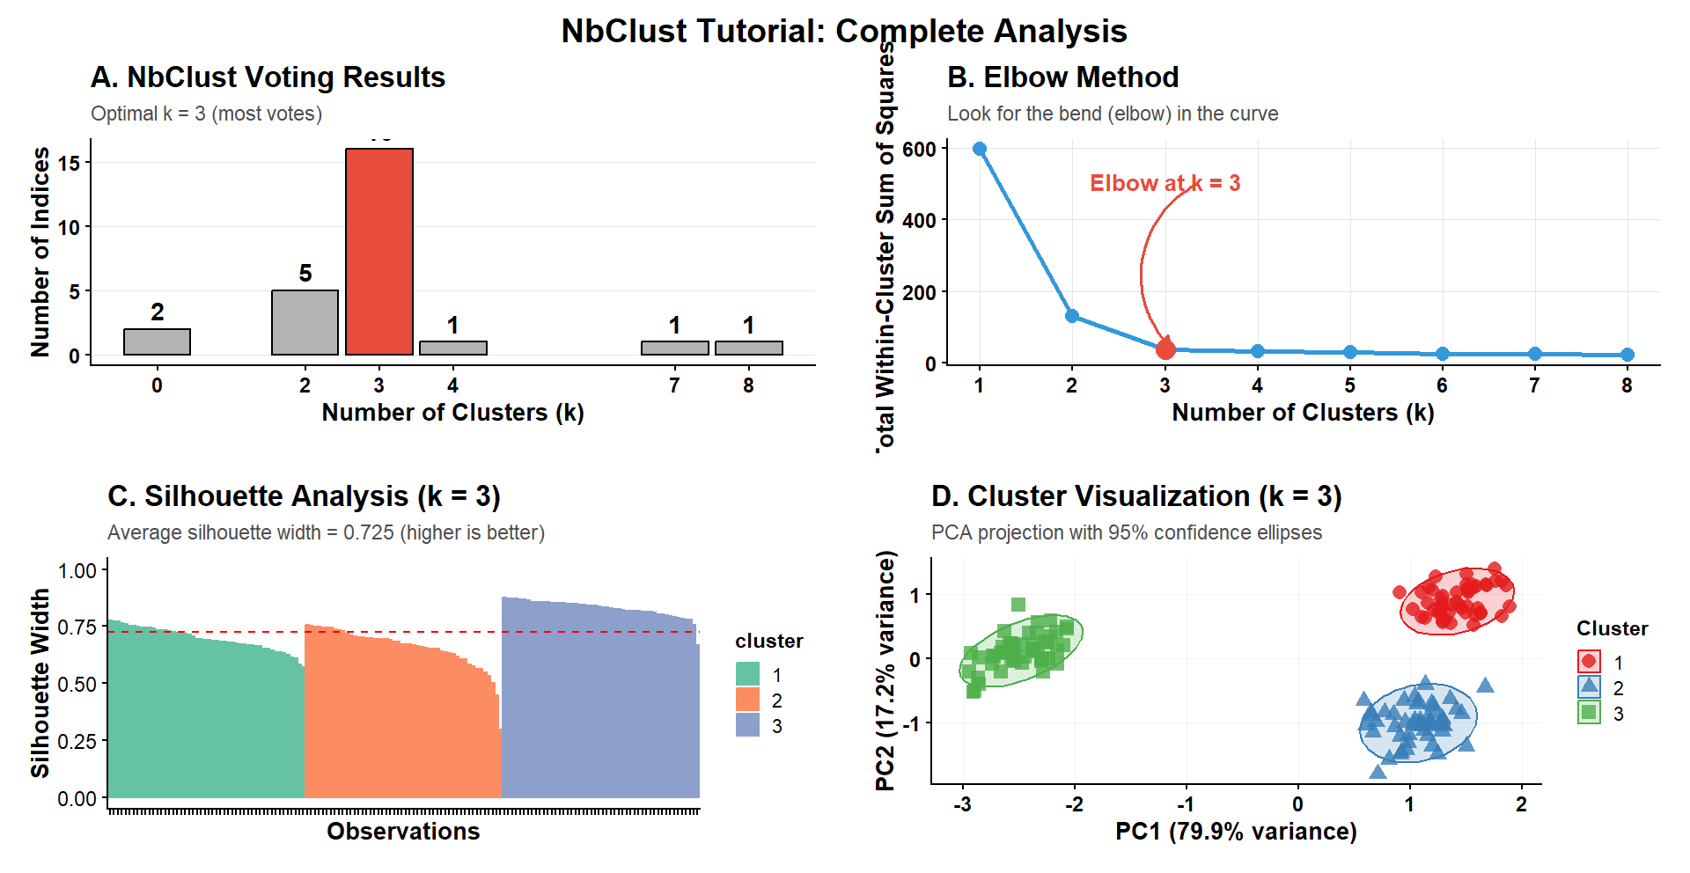

III. Dist Computation
# 1. We will start by computing the distance matrix using different methods.
Euclidean = Straight-line distance between two points
Manhattan = Distance travelling only horizontally/vertically (like city blocks)
# 2. Next, we will compute the distance matrix after standardizing the data.
# 3. Finally, we will visualize the distance matrices.
- Comparison between Euclidean and Manhattan:
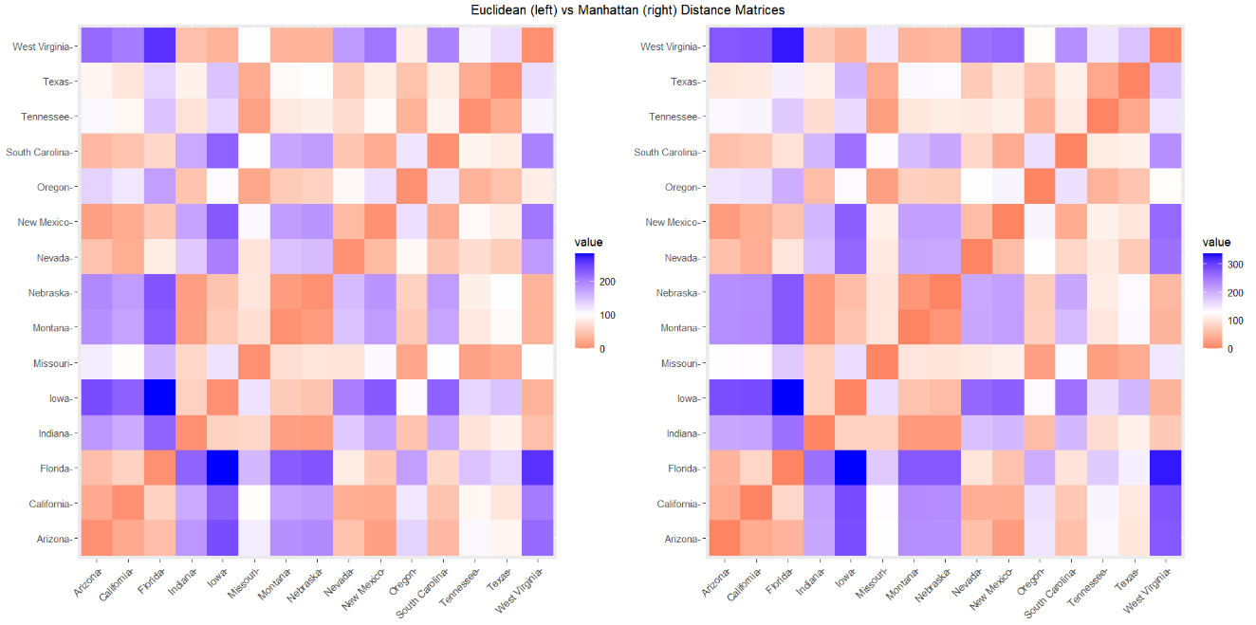
- Data Standardization:
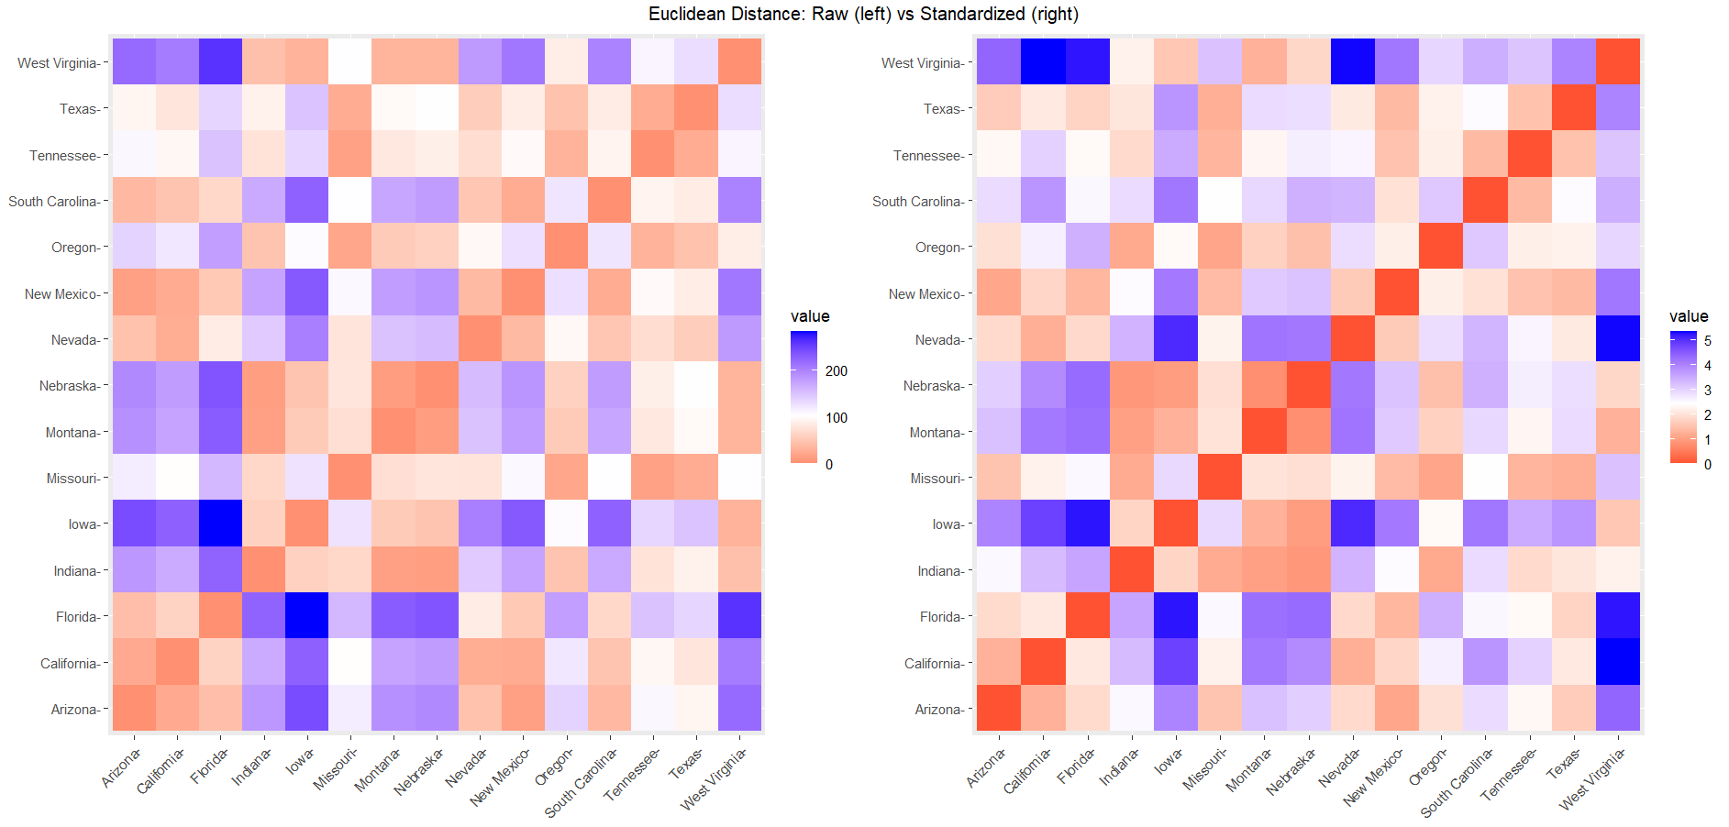
Raw data | Standardized data
Distances are driven by largest variable | All variables contribute equally
Variables with similar profiles cluster together | Variables with overall similar profiles cluster together
Heatmap patterns reflect one variable | Heatmap patterns reflect all variables

IV. Clustering
# 1. We will identify clusters using k-means and hierarchical clustering.
# 2. Next, we will visualize the obtained clusters and we will combine clustering with dimention reduction methods.
- Clustering with K mean:
  - Kmeans (x, centers, iter.max = 10, nstart = 1)
    - X = numeric matrix, numeric data frame or a numeric vector#
    - Centers = possible values are the number of clusters (k) or a set of initial (distinct) cluster centers. If a number, a random set of (distinct) rows in x is chosen as the initial centers.
    - iter.max = the maximum number of iterations allowed.
      - Default value is 10.
    - nstart = the number of random starting partitions when centers is a number.
      - Trying nstart > 1 is often recommended.
  - Within sum of square (WSS):
    - Graph drawn according to the number of clusters. The location of a bend (knee) in the plot is generally considered as an indicator of the appropriate number of clusters.
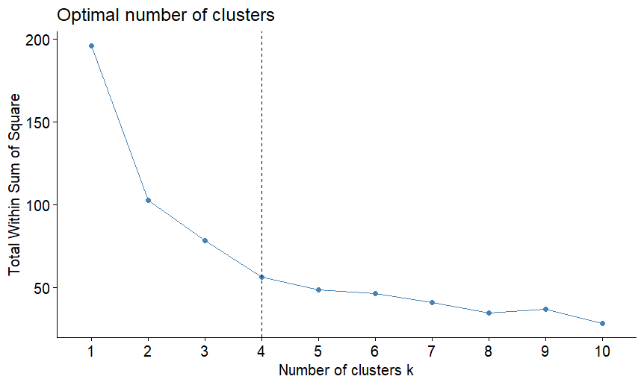

  - Then, compute k-means with optimal number of clusters, ex) k = 4
  - Compute the mean of each variables of each cluster?
  - For multi-dimensional data set (more than one variable), we can perform Principal Component Analysis (PCA) and to plot data points according to the first two principal components coordinates:
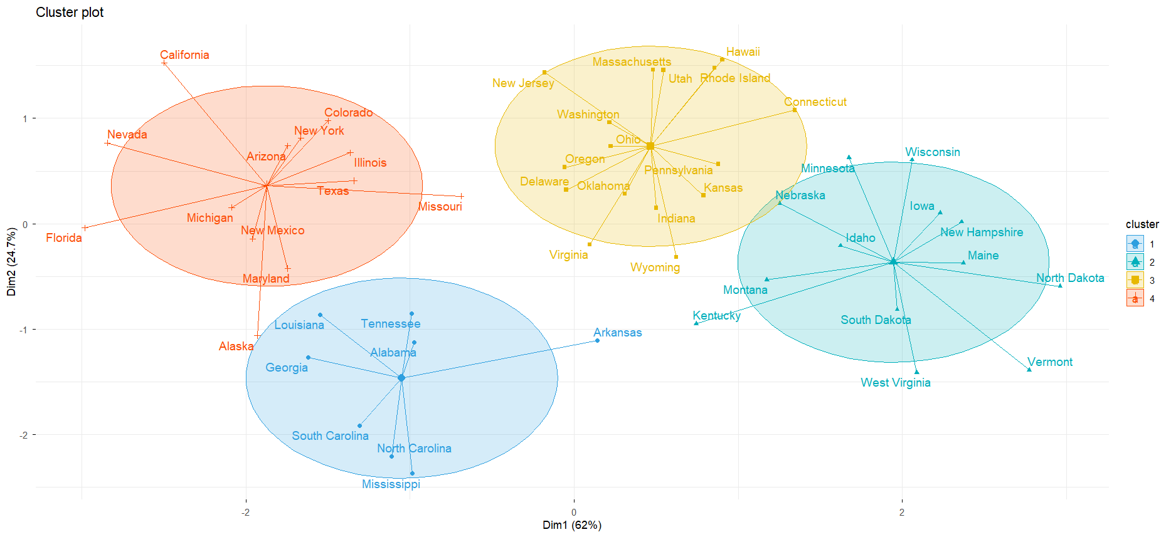
- Clustering with PAM:
  - Pam (x, k, metric = "euclidean", stand = FALSE)
    - X = possible values includes:
      - Numeric data matrix or numeric data frame: each row corresponds to an observation, and each column corresponds to a variable.
      - Dissimilarity matrix in this case x is typically the output of daisy() or dist()
    - K = the number of clusters metric: the distance metrics to be used. Available options are "euclidean" and "manhattan".
    - Stand = logical value; if true, the variables (columns) in x are standardized before calculating the dissimilarities. Ignored when x is a dissimilarity matrix.

  - Estimate the optimal number of clusters
  - Then, compute k-means with optimal number of clusters, ex) k = 2
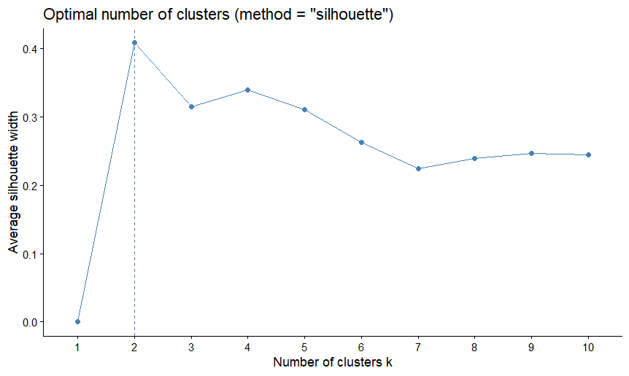
  - If we have a multi-dimensional data set (more than one variable), we can perform Principal Component Analysis (PCA) and to plot data points according to the first two principal components coordinates:
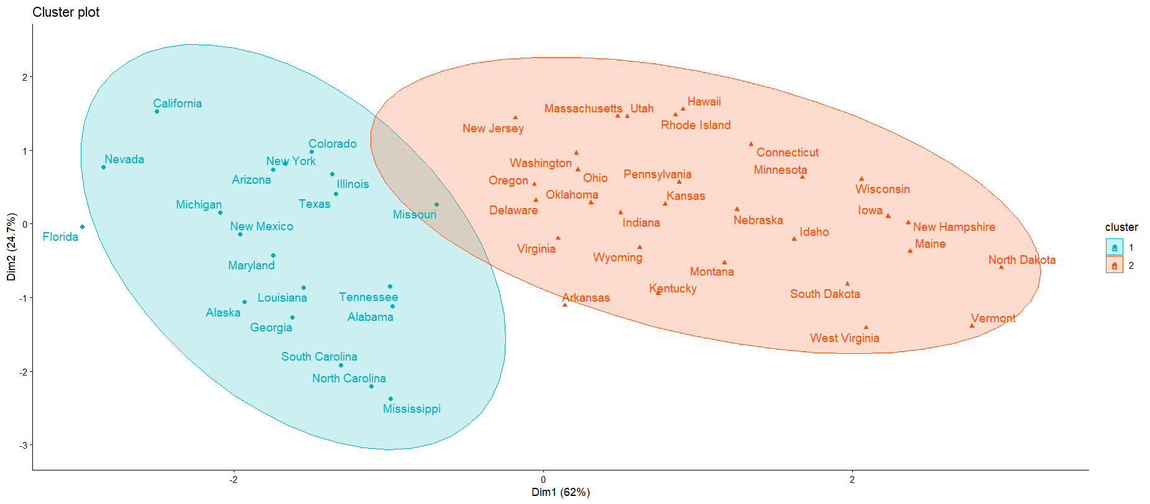

- Hierarchical clustering:
  - To compute the dissimilarity matrix
  - df = the standardized data
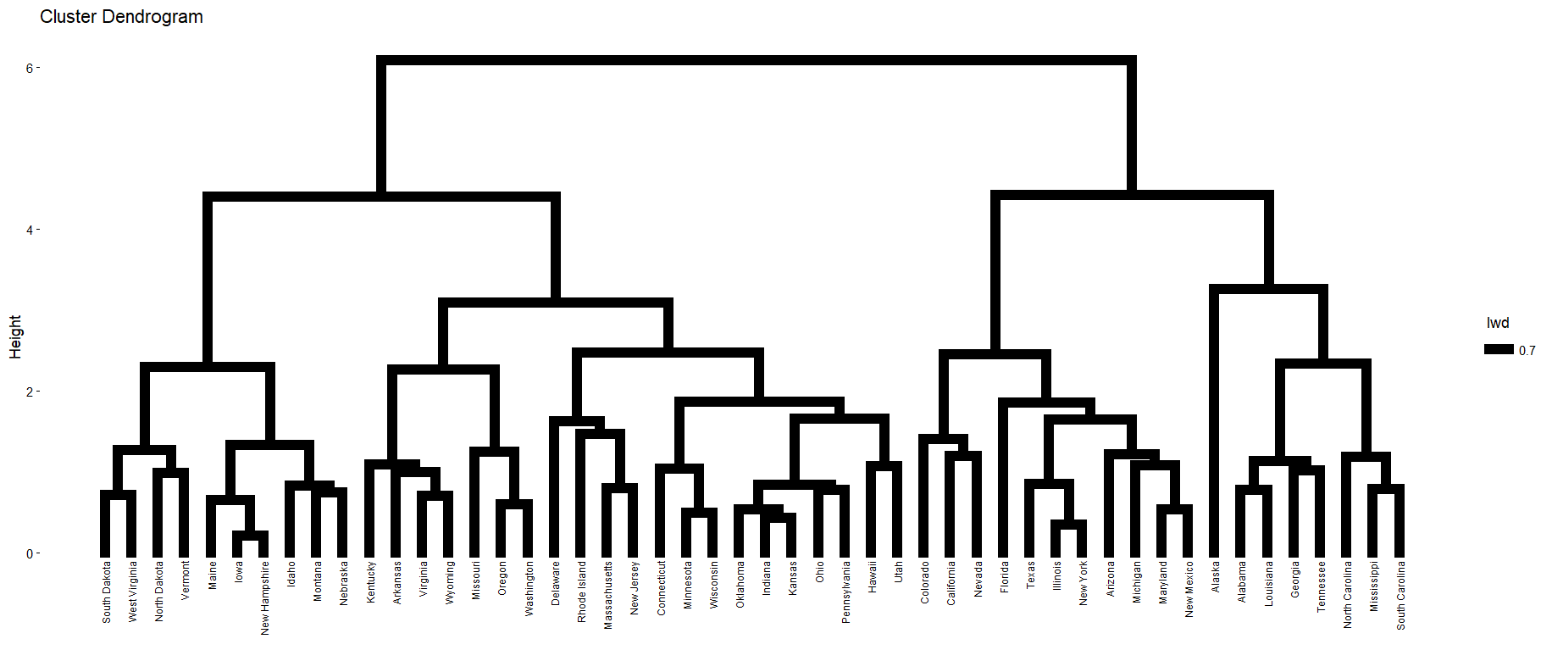
  - However, hierarchical clustering does not tell us how many clusters there are, or where to cut the dendrogram to form clusters. Thus, we have cut them into groups:
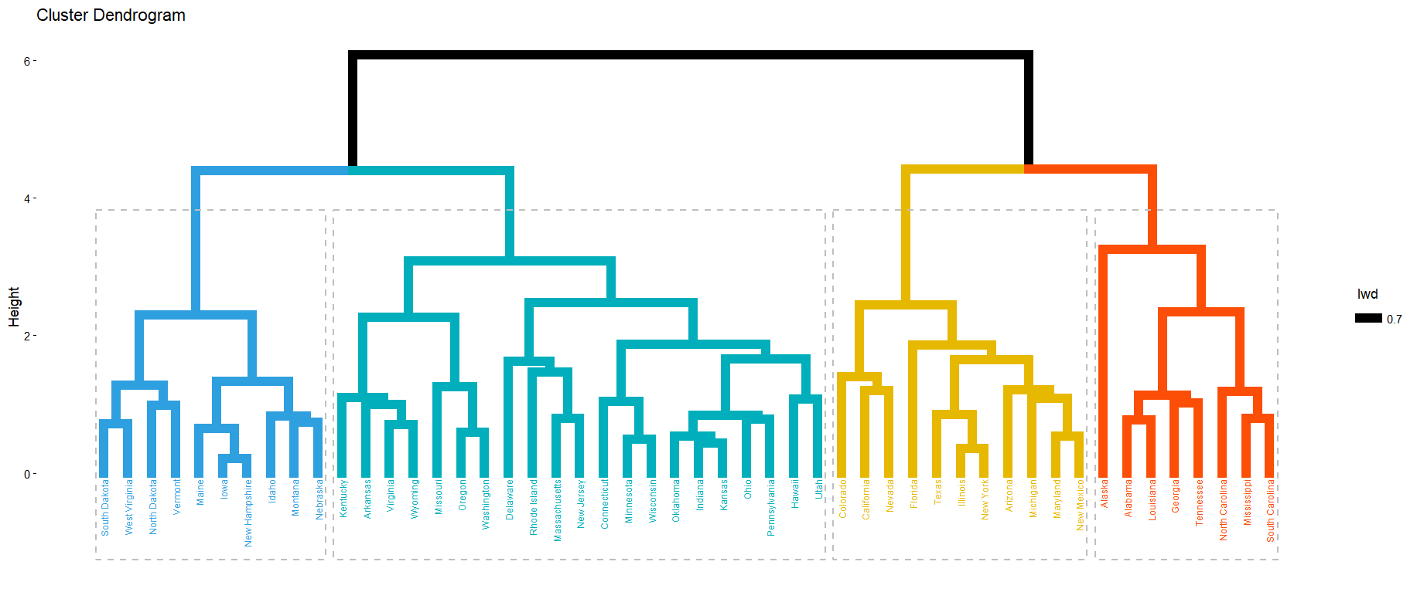

  - Optional visualization (circular):
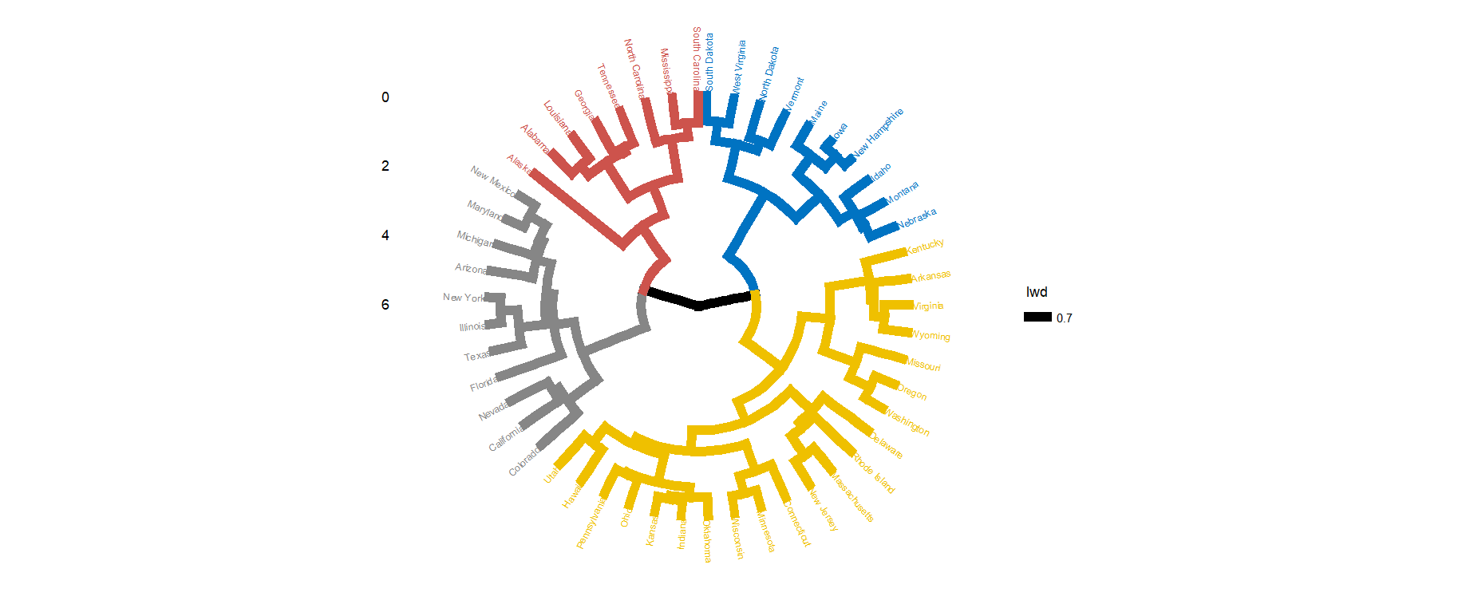
  - Optional visualization (phylogenic tree):
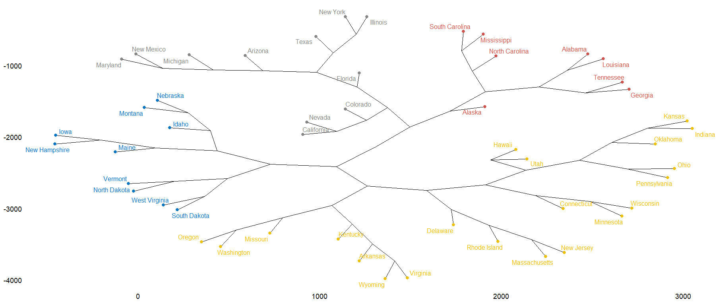

V. Cluster Validation
# 1. We'll start by describing the different measures in the clValid package for comparing clustering algorithms.
# 2.Next, we'll present the function *clValid*().
# 3. Finally, we'll provide R scripts for validating clustering results and comparing clustering algorithms.
- Internal Validation:
  - intern <- clValid(df, nClust = 2:6, clMethods = clmethods, validation = "internal")
    - This tests how compact and well-separated clusters are using 3 metrics:
      - Connectivity
        - How connected neighbouring points are
      - Dunn Index
        - Ratio of between-cluster to within-cluster distance
      - Silhouette
        - How similar a point is to its own cluster vs others
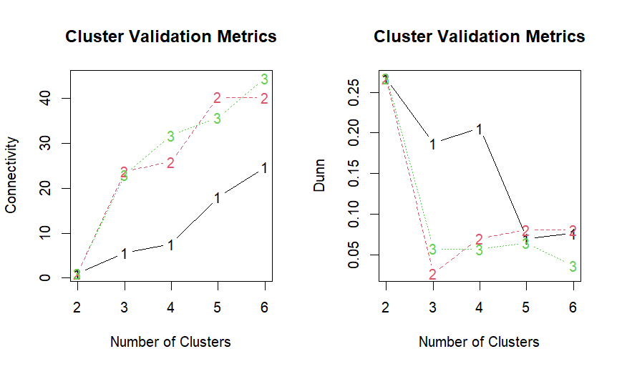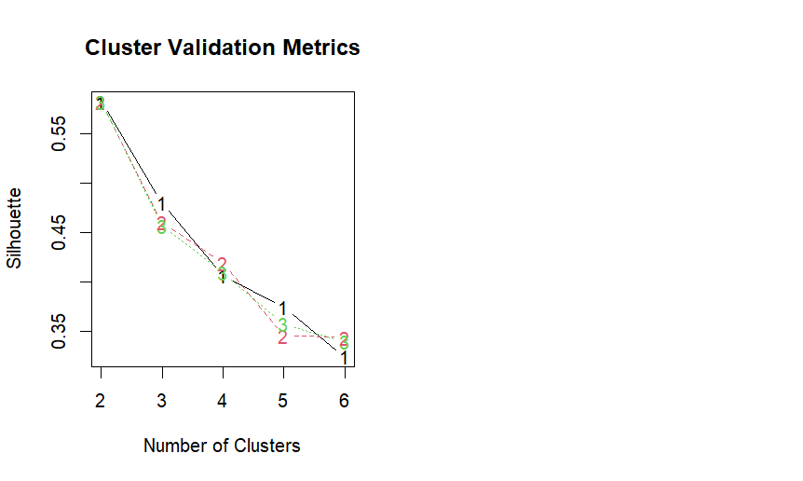

- Stability Validation:
  - stab <- clValid(df, nClust = 2:6, clMethods = clmethods, validation = "stability")
    - This tests how stable clusters are when data is slightly changed — specifically by removing one column at a time and re-clustering:
      - APN
        - How often observations stay in the same cluster when a column is removed
      - AD
        - Average distance between observations in same cluster across both runs
      - ADM
        - Average distance between cluster centers across both runs
      - FOM
        - Variance of the removed column within clusters
- Summary:
  - Hierarchical clustering with k=2 wins on APN and ADM most stable structure
  - PAM with k=6 wins on AD and FOM most precise groupings
  - This tells you there's no single perfect answer; the best method depends on what you prioritize

